Contents
1.0 Create GCP Project: 1
2.1 Install Binaries on Ubuntu - kubectl. 2
2.2 Install Binaries on Ubuntu - gcloud 3
2.3 Install Binaries on Ubuntu - GIT 4
3.1 Verify Google Cloud Project Info 4
4.0 Clone Microservice Demo 5
5.1 Authenticate to Google Cloud 6

1.0 Create GCP Project:
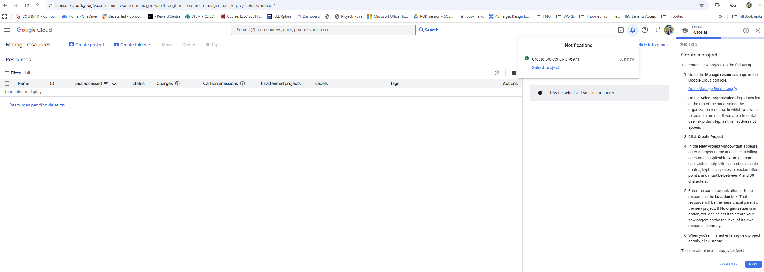
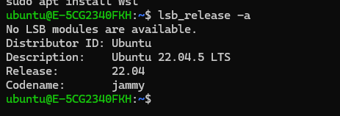

2.1 Install Binaries on Ubuntu - kubectl.
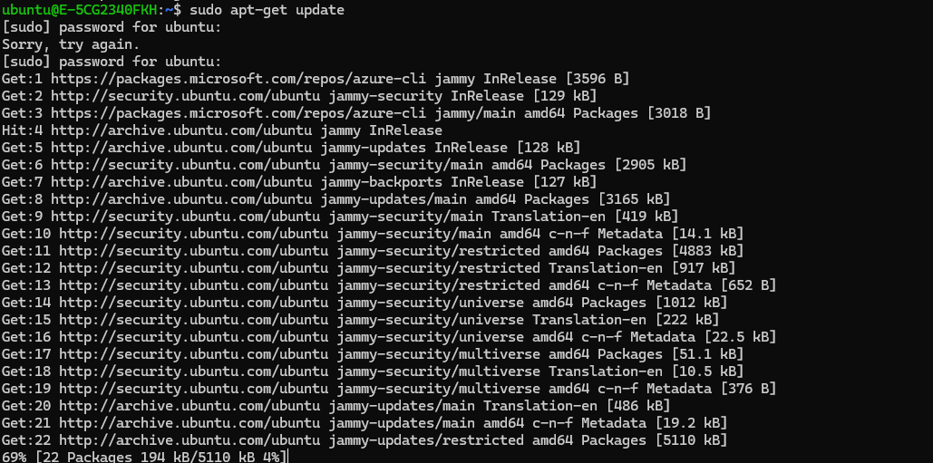

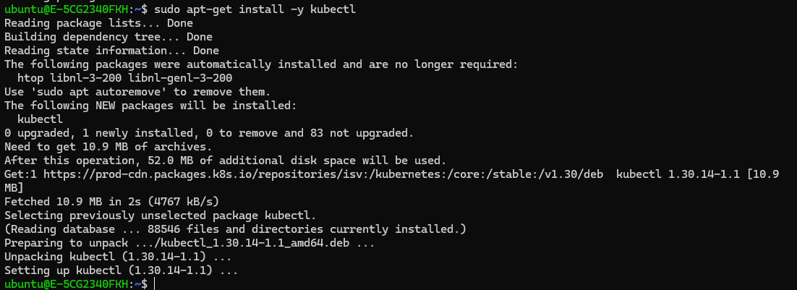

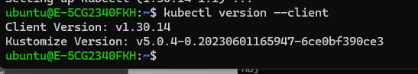

2.2 Install Binaries on Ubuntu - gcloud
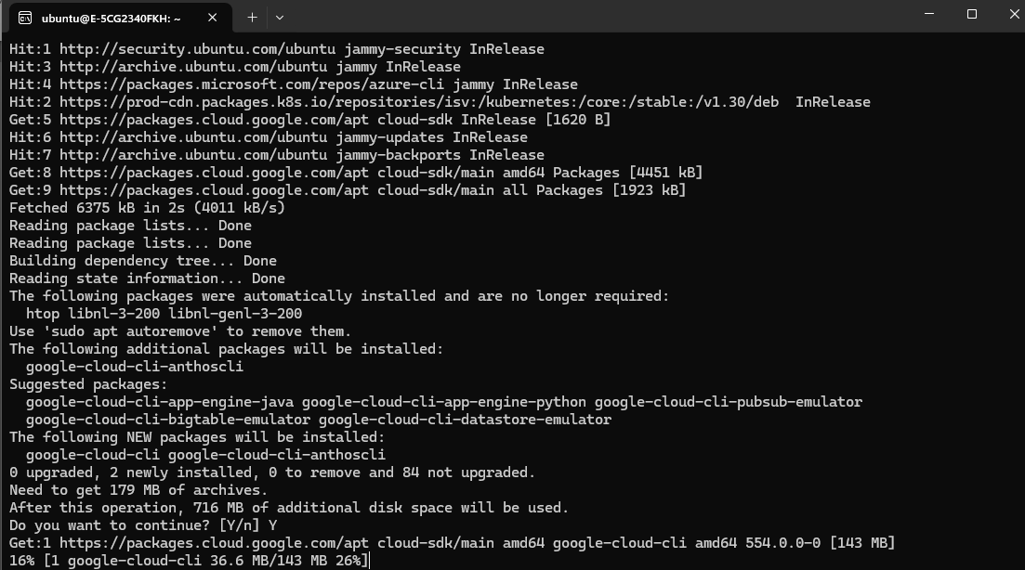

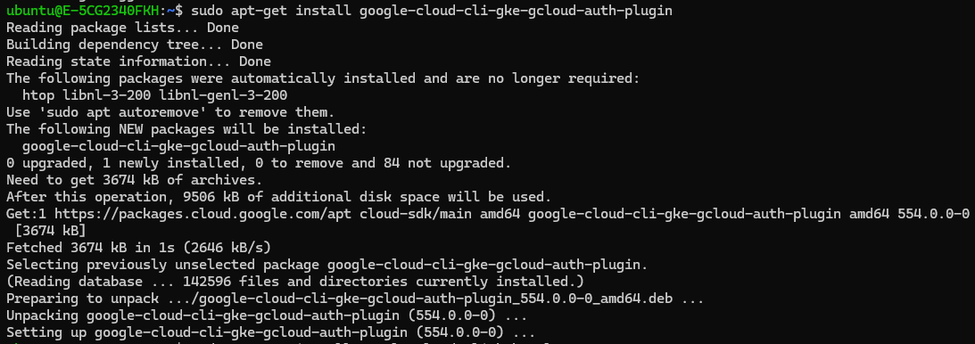
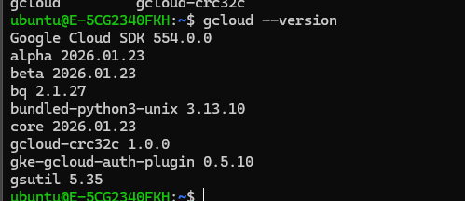

2.3 Install Binaries on Ubuntu - GIT
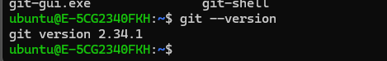

3.1 Verify Google Cloud Project Info
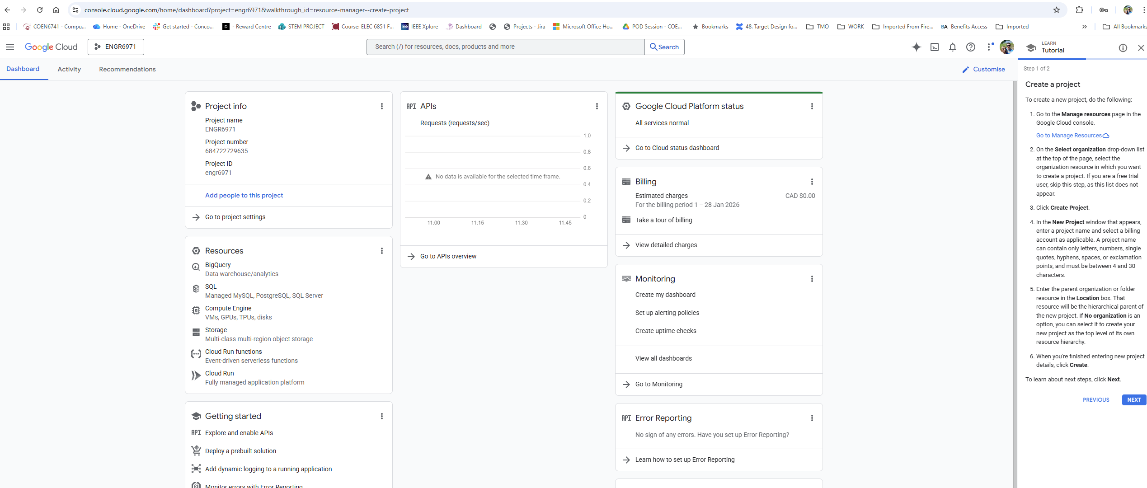

4.0 Clone Microservice Demo
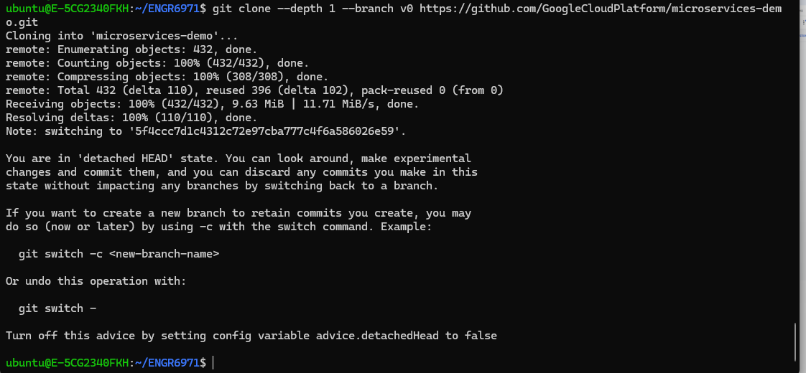

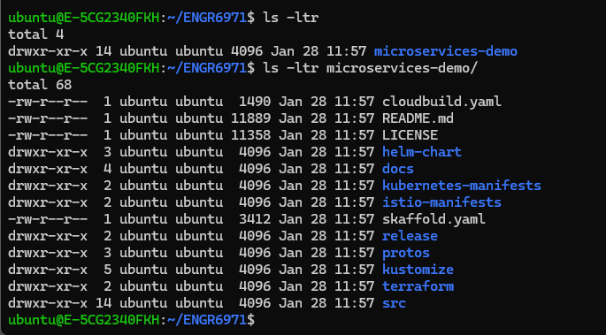

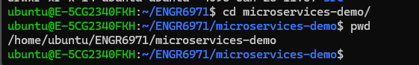

5.1 Authenticate to Google Cloud
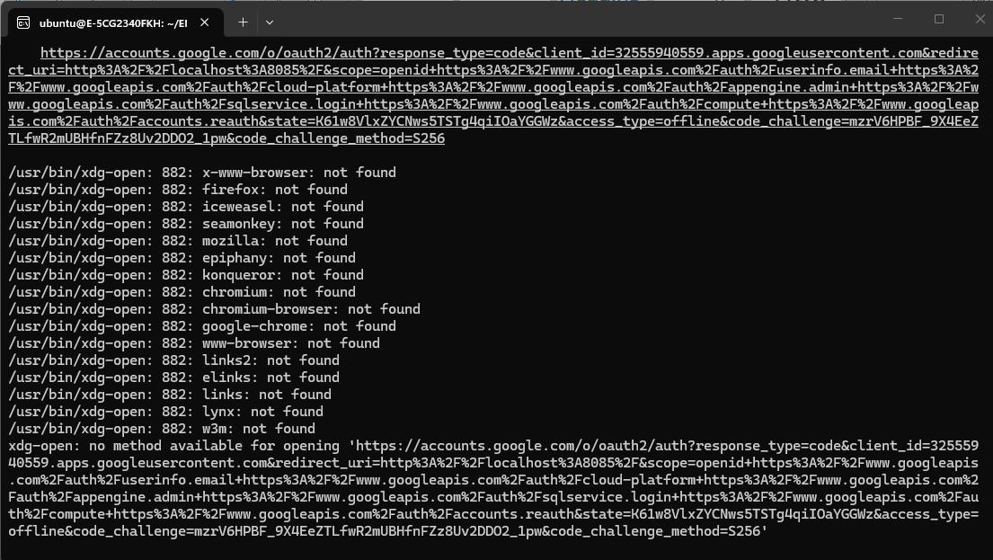
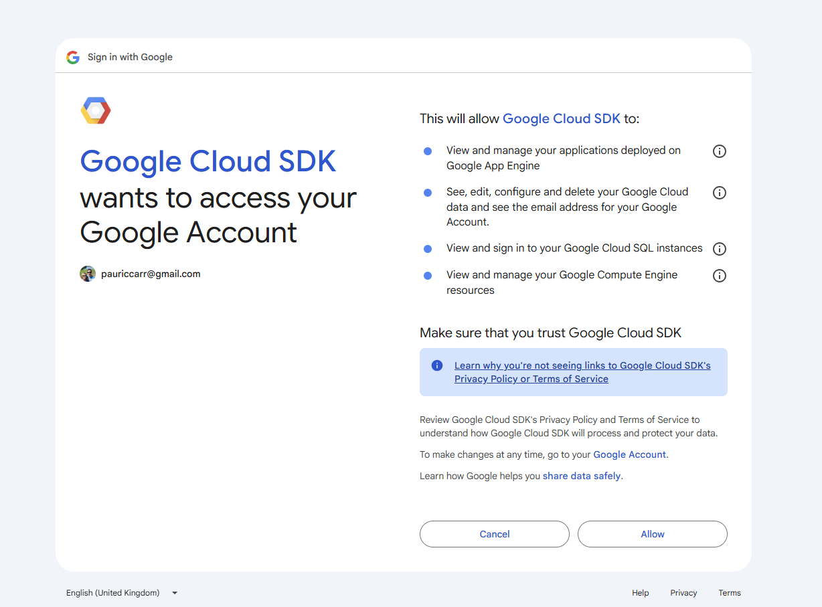
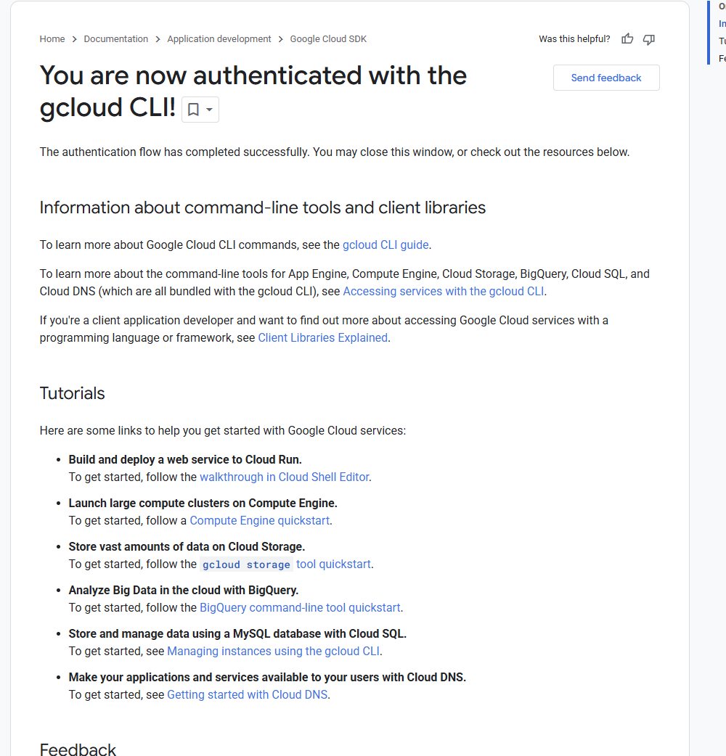
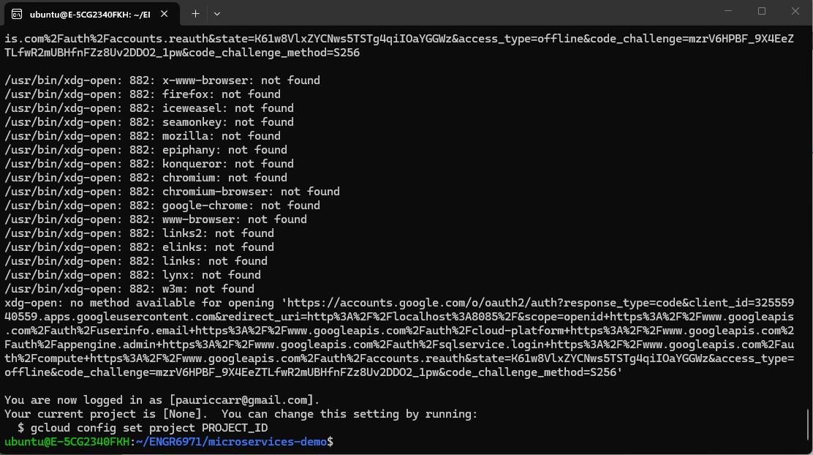
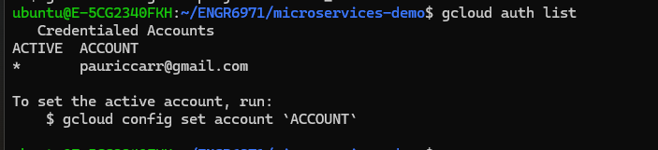

5.2 – Enable GKE

5.3 Set GCLOUD Project Environment Variables
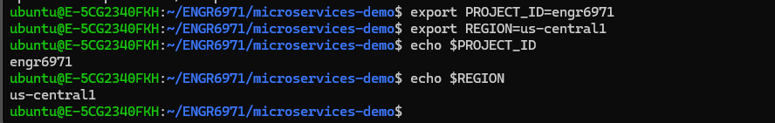

5.4 Create a GKE Cluster
NOTE – Can take 10-15 Mins to create

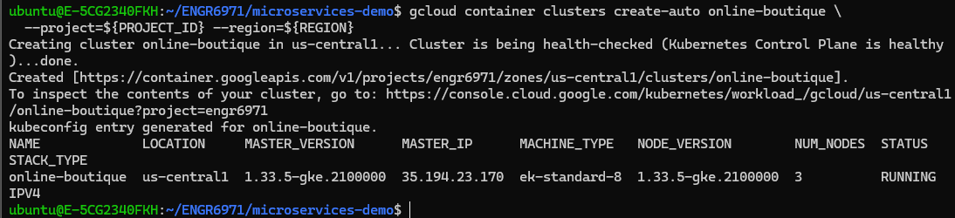
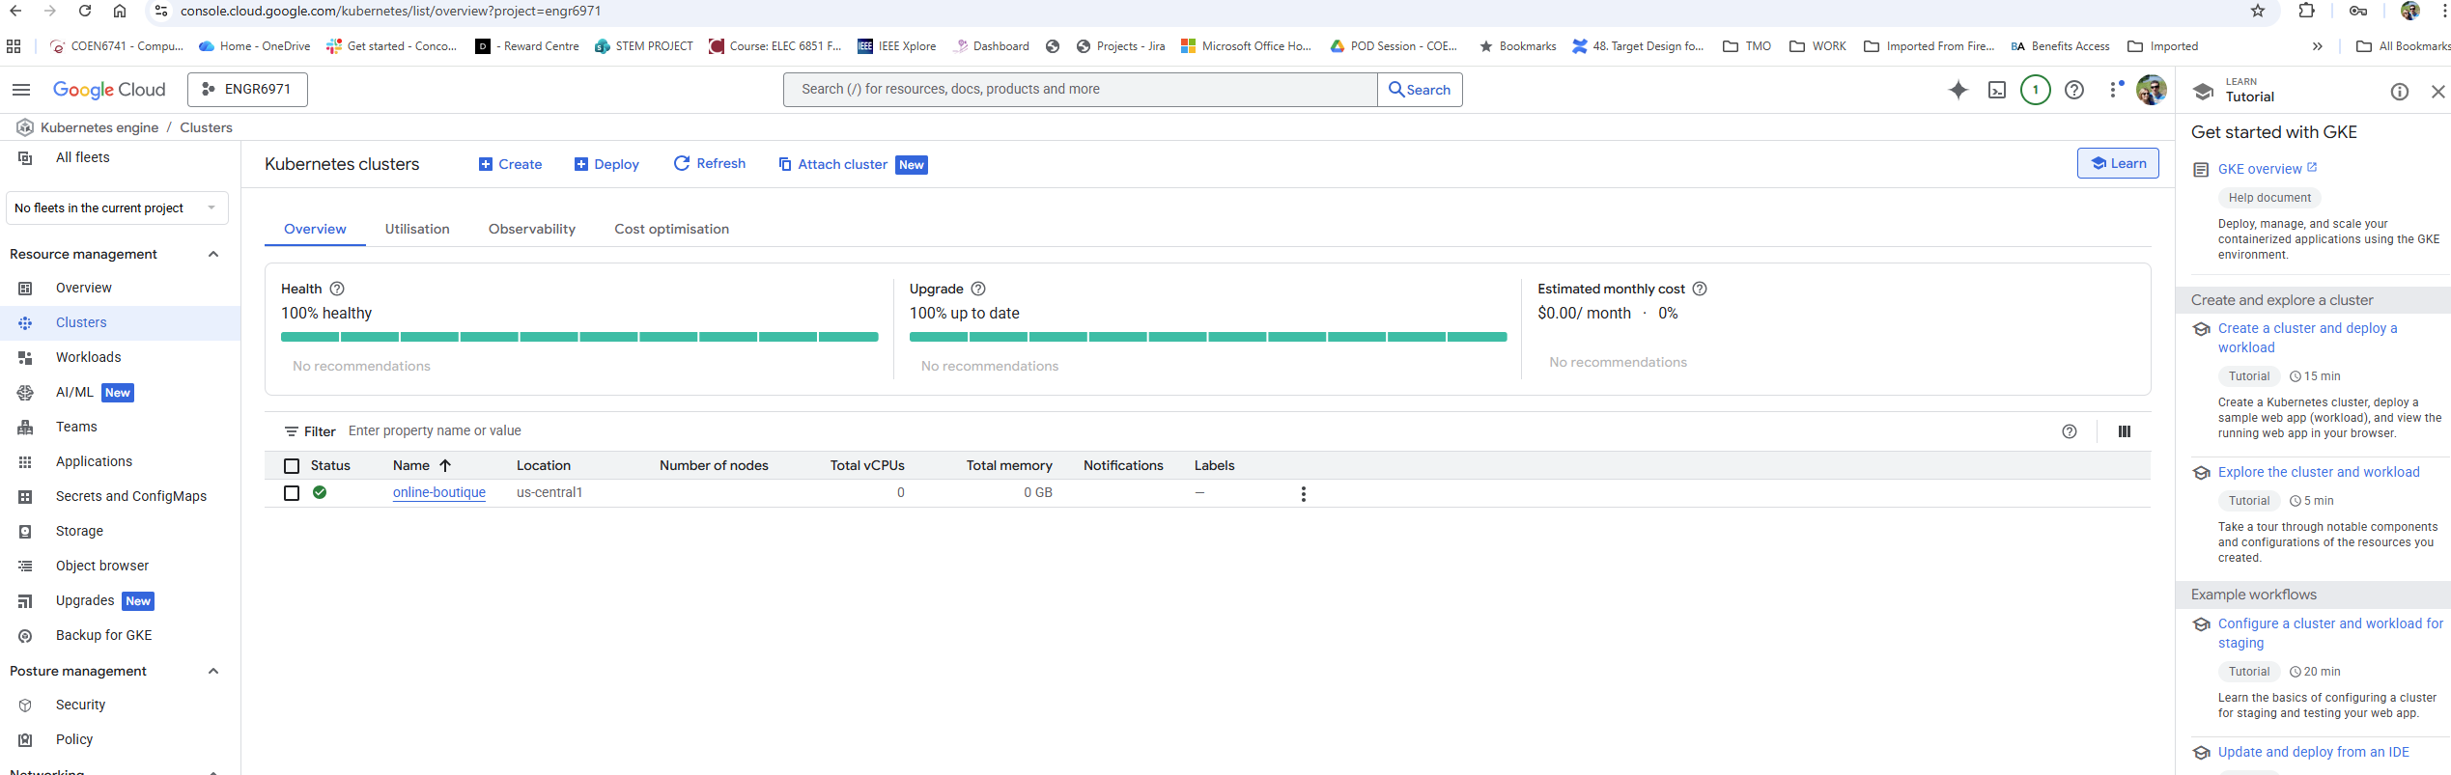

6.1 Deploy the Online Boutique into the Cluster:
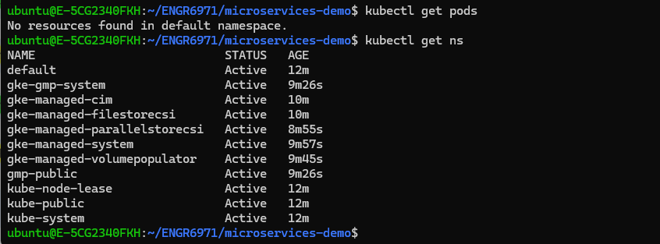
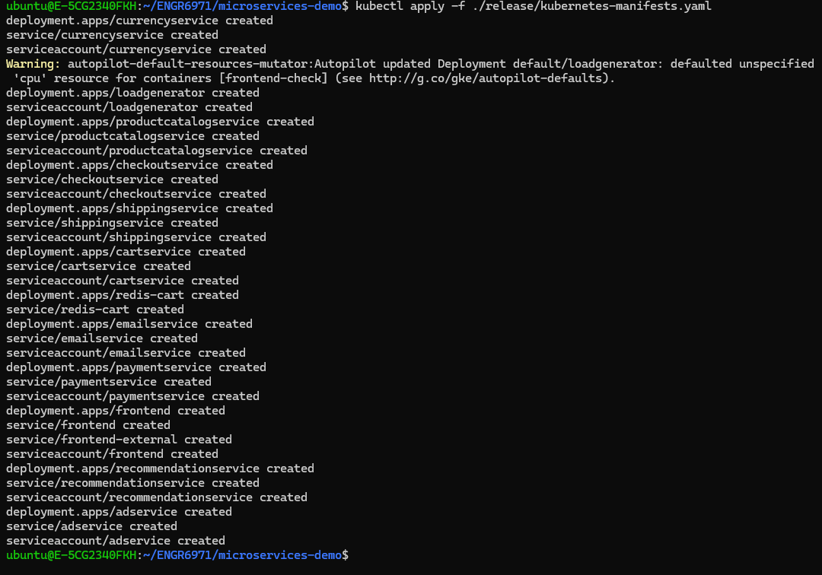
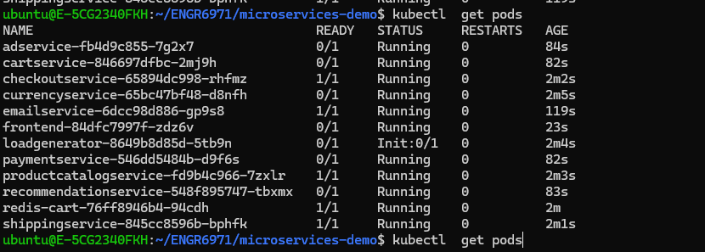

PODs come up after 5 mins approx.
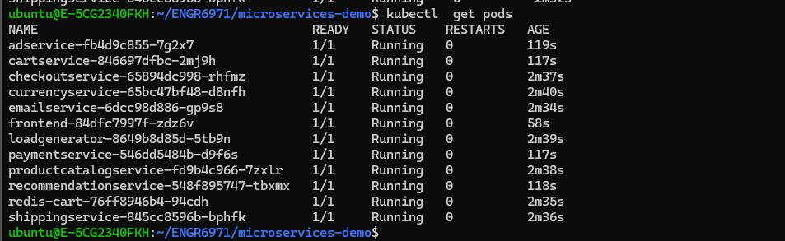
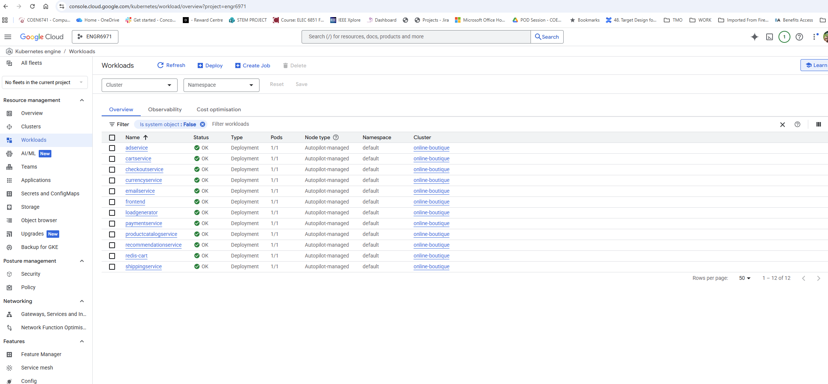

6.1 Find the Frontend External IP:

6.2 Online Boutique
